13.59: a) For SHM, the period, frequency and angular frequency are independent of amplitude, and are not changed. b) From Eq. (13.31), the energy is decreased by a factor of . c) From Eq. (13.23), the maximum speed is decreased by a factor of d) Initially, the speed at 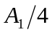 was 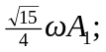 after the amplitude is reduced, the speed is 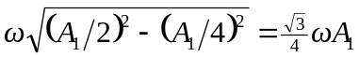, so the speed is decreased by a factor of 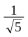 (this result is valid at 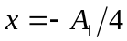 as well). e) The potential energy depends on position and is unchanged. From the result of part (d), the kinetic energy is decreased by a factor of .

